***Statistics Notes - 3***

***Discrete Probability Distribution:***

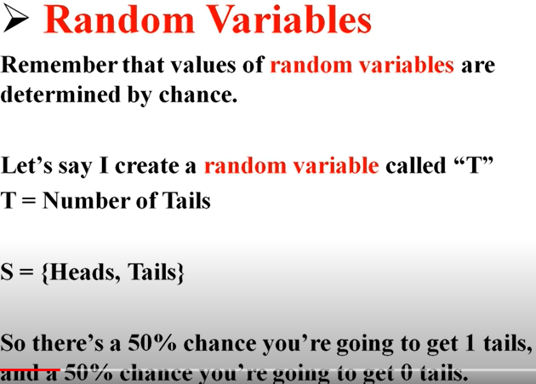

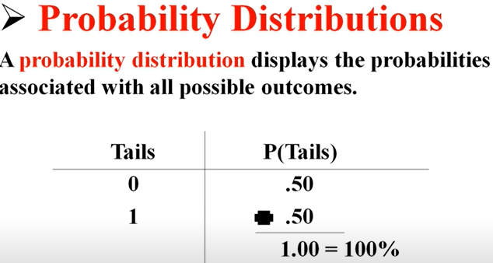

Below is the another example

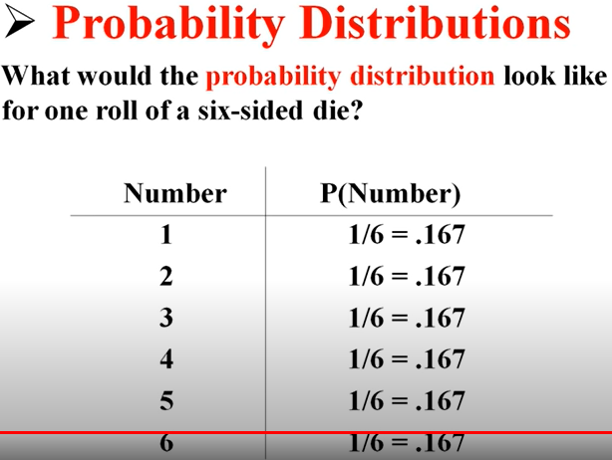

***Probability Histograms***

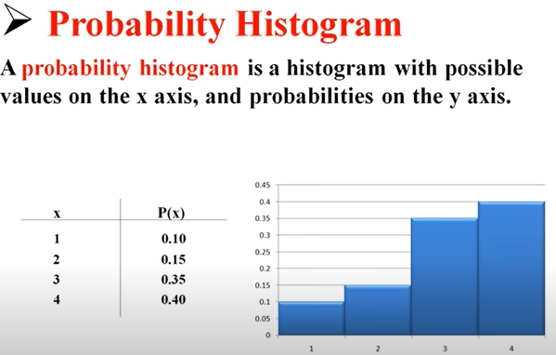

***Mean and Expected Value of Discrete Random Variable***

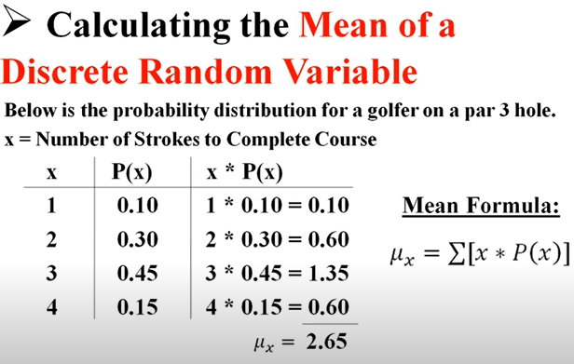

***Variance and Standard Deviation of Discrete Random Variable***

Example continue with last example i.e. calculation of Mean.

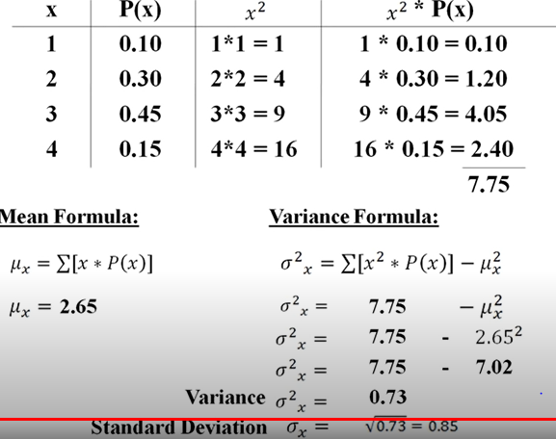

***The Law of Large Number***

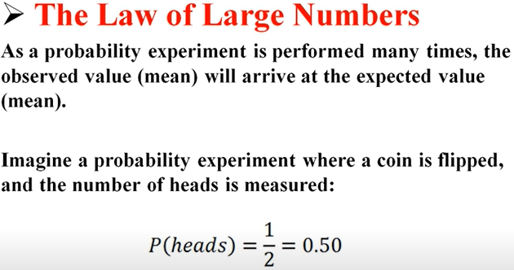

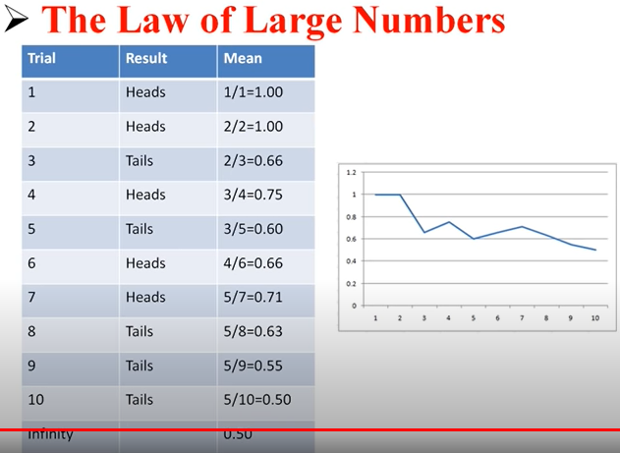

In the above example if we see in the 1st trial mean is different but after large number of experiment we came to actual expected value i.e 0.50 as per 1st screen shot of example.

***Binominal Distribution:***

A **binomial distribution** can be thought of as simply the probability of a SUCCESS or FAILURE outcome in an experiment or survey that is repeated multiple times. The binomial is a type of distribution that has **two possible outcomes** (the prefix “[bi](http://membean.com/wrotds/bi-twice)” means two, or twice).

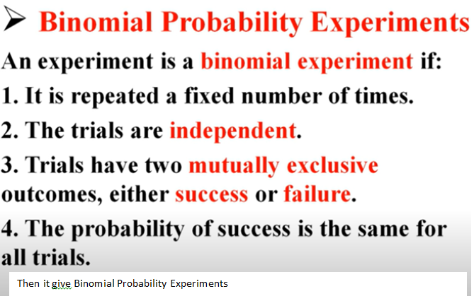

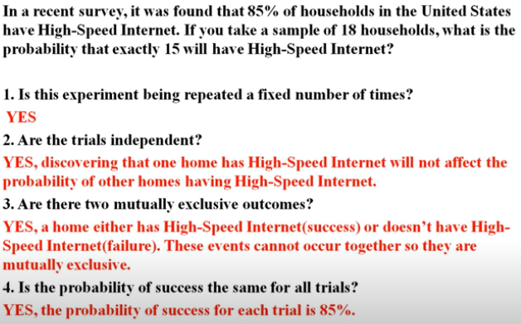

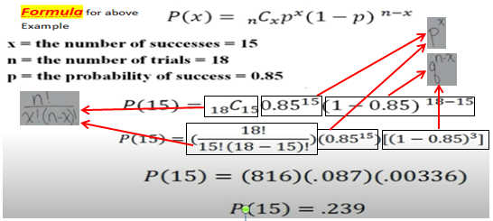

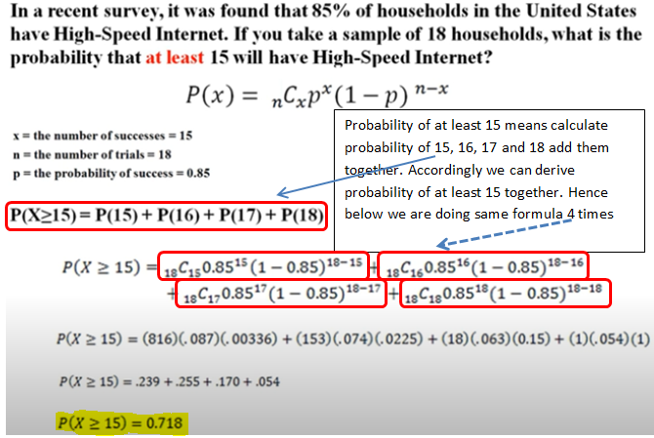

***Mean and Standard Deviation of Binomial Random Variable***:

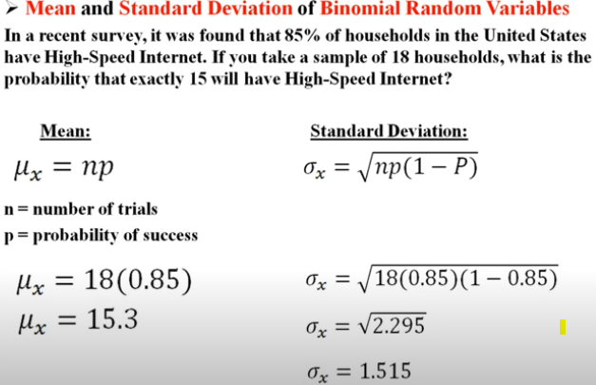

***The Poisson distribution***:

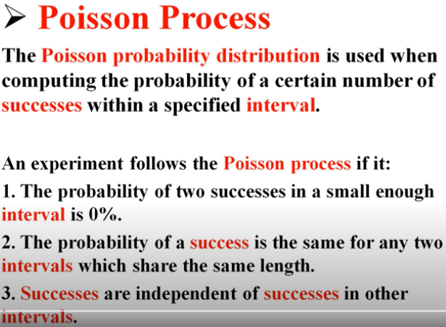

***Mean and Standard Deviation of Poisson Random Variable***:

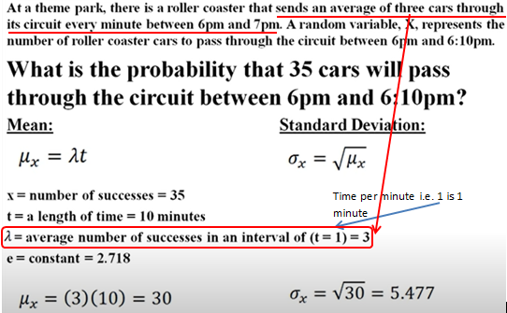

***Coordinate (Cartesian) Planes***:

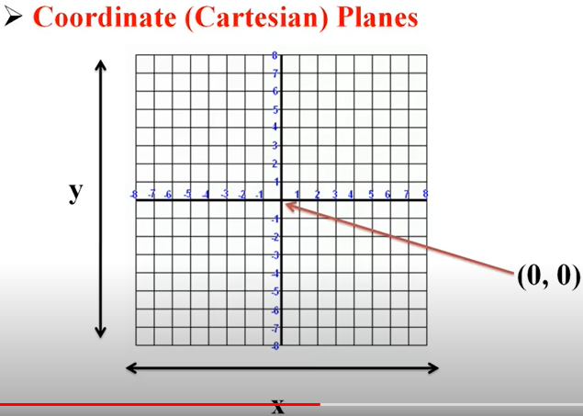

***Quadrants:***

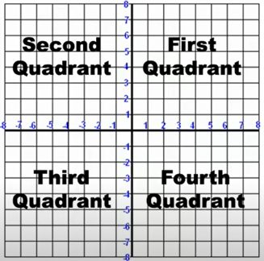 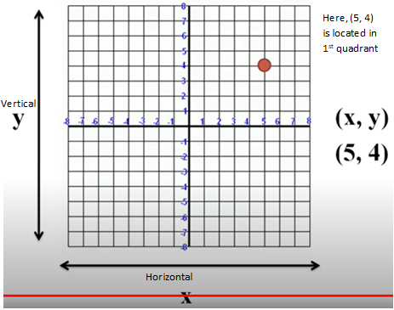

***Scatter Plot***:

